Checkout:
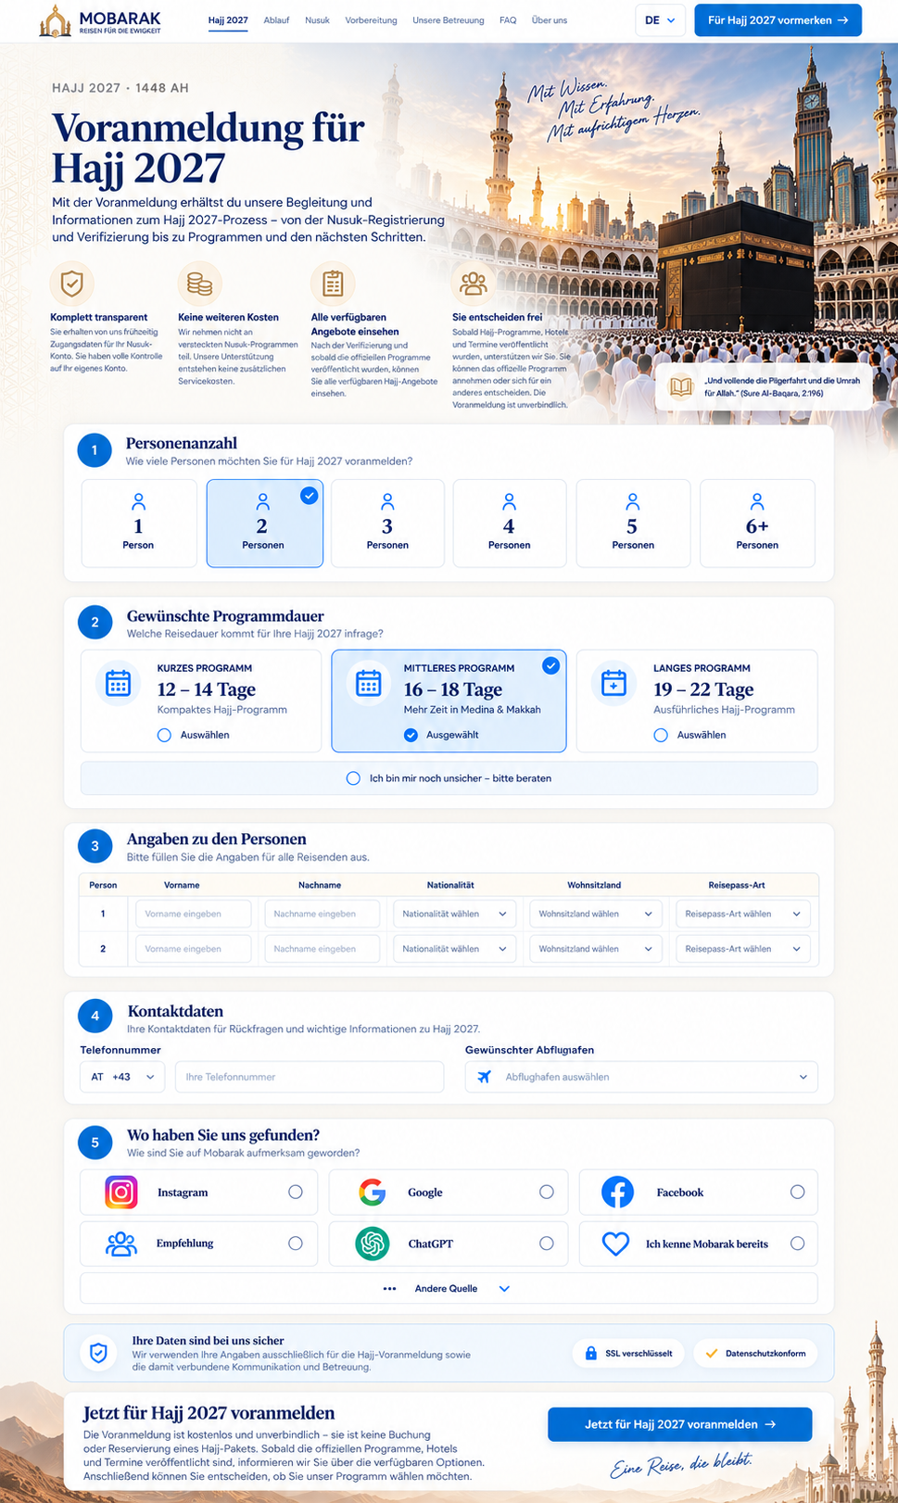
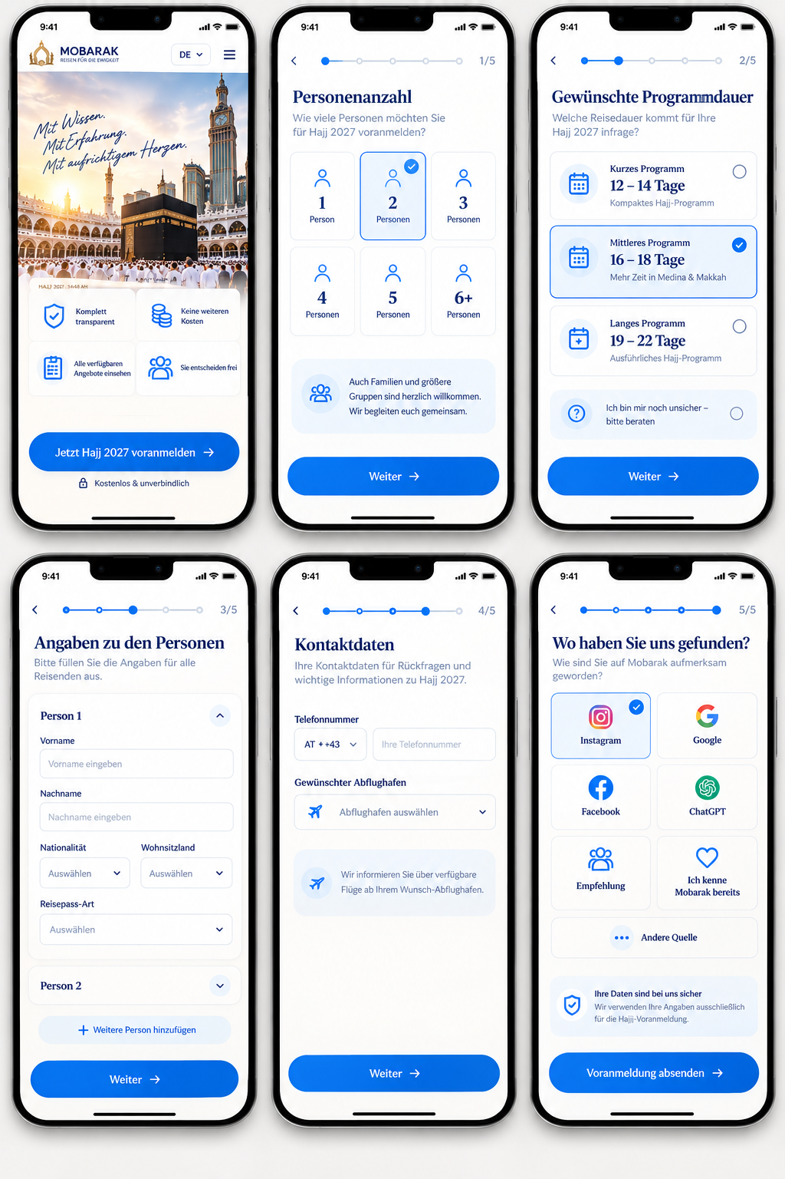

Hajj 2027 Pre-Registration – Final Implementation Brief
Please implement the desktop and mobile versions exactly according to the two approved reference designs I provided.
These are now the final design direction. Please do not redesign the page or introduce a different visual concept. The goal is to reproduce this design professionally, responsively, and with the functionality described below.
The desktop and mobile versions should clearly belong to the same Mobarak brand, but the mobile version should feel like a modern app-style registration flow, not simply a stacked version of the desktop page.

1. Overall Design System
Please follow the visual language of the approved designs:
- White / warm off-white background
- Dark navy for headlines and important text
- A pleasant, softer Mobarak blue for buttons, active states, progress indicators and links
- Subtle warm gold/beige accents
- White cards
- Very subtle shadows
- Thin light borders
- Rounded corners
- Generous whitespace
- Clean modern icons
- Premium but calm appearance
Please avoid an overly bright/electric blue.
The blue should feel premium, calm and trustworthy and must be consistent throughout the entire Hajj website.

DESKTOP VERSION
The desktop version should remain a single-page registration form, exactly as shown in the approved desktop reference.
2. Header
Left:
Mobarak logo
Main navigation:
- Hajj 2027
- Ablauf
- Nusuk
- Vorbereitung
- Unsere Betreuung
- FAQ
- Über uns
Right:
DE ▾
Primary CTA:
Für Hajj 2027 vormerken →
The header should remain clean and relatively compact.

3. Hero Section
Please reproduce the approved hero design.
Left side
Small label:
HAJJ 2027 · 1448 AH
Headline:
Voranmeldung für Hajj 2027
Description:
Mit der Voranmeldung erhältst du unsere Begleitung und Informationen zum Hajj-2027-Prozess – von der Nusuk-Registrierung und Verifizierung bis zu Programmen und den nächsten Schritten.
Right side
Use the large emotional Makkah / Kaaba image as shown in the design.
Keep the handwritten visual text:
Mit Wissen.
Mit Erfahrung.
Mit aufrichtigem Herzen.
The image and left content should blend together naturally rather than look like two separate boxes.

4. Four Benefits in the Hero
Keep the four benefit blocks shown in the approved design:
Komplett transparent
The customer receives access to their own Nusuk account and keeps full control of it.
Keine weiteren Kosten
There are no additional service charges from us outside the official Nusuk process.
Alle verfügbaren Angebote einsehen
After verification and once the official programs are published, customers can view the available Hajj options.
Sie entscheiden frei
The pre-registration is non-binding. Once programs, hotels and dates are available, the customer can decide which official option they want.
Please keep the icons elegant and consistent with the rest of the design.

5. Step 1 – Number of Travelers
Title:
Personenanzahl
Subtitle:
Wie viele Personen möchten Sie für Hajj 2027 voranmelden?
Options:
1 2 3 4 5 6+
Each option should be presented as a selectable card.
Selected state
When selected:
- very light blue background
- blue border
- blue/white checkmark in the top-right corner
- clearly distinguishable from unselected options
Only one option can be selected.

6. Step 2 – Preferred Program Duration
Title:
Gewünschte Programmdauer
Subtitle:
Welche Reisedauer kommt für Ihre Hajj 2027 infrage?
There must be four possible selections.
Option 1
KURZES PROGRAMM
12–14 Tage
Kompaktes Hajj-Programm
Option 2
MITTLERES PROGRAMM
16–18 Tage
Mehr Zeit in Medina & Makkah
Option 3
LANGES PROGRAMM
19–22 Tage
Ausführliches Hajj-Programm
Option 4
Ich bin mir noch unsicher – bitte beraten
Important: the fourth option is a real selectable option, not just informational text.
Only one program-duration option can be selected at a time.

7. Step 3 – Traveler Details
Title:
Angaben zu den Personen
Subtitle:
Bitte füllen Sie die Angaben für alle Reisenden aus.
For each traveler collect:
- First name
- Last name
- Nationality
- Country of residence
- Passport type
The number of traveler forms must be dynamically generated according to the number selected in Step 1.

IMPORTANT: Nationality Must Be Free Text
Please change the current implementation.
Nationality must NOT be a dropdown/select field.
It must always be a normal text input.
Label:
Nationalität
Placeholder:
Nationalität eingeben
For example, the customer may freely enter:
Österreichisch
Deutsch
Bosnisch
Türkisch
Syrisch
etc.
Do not restrict nationality to a predefined list.

8. Country of Residence
Wohnsitzland may remain a dropdown/select field.

9. Passport Type
Passport type remains a selectable field.
However, the default value must already be:
Normaler Reisepass
The customer should therefore not be required to manually select the normal passport option.
Possible additional options can include:
- Normaler Reisepass
- Diplomatenpass
- Dienstpass
- Sonstiger Pass
But:
Default = Normaler Reisepass

10. Step 4 – Contact Details
Title:
Kontaktdaten
The form should contain:
Phone Number
Country code selector + telephone number.
Example:
AT +43 | Ihre Telefonnummer

REMOVE THE EMAIL FIELD
The email address field should be removed completely.
Instead, this position should be used for:
Gewünschter Abflughafen
However, there is an important functionality requirement here.

11. Departure Airports – Free Text + Multiple Airports
The departure airport must NOT be a predefined dropdown.
The user must be able to freely type the airport or city.
Label:
Gewünschter Abflughafen
Placeholder:
Abflughafen eingeben
For example:
Wien
München
Frankfurt
Zürich
Bratislava
etc.
Multiple departure airports must be possible.
A customer may be flexible and want to indicate several possible departure airports.
Therefore, after entering an airport, convert it into a removable chip/tag.
Example:
Wien × München × Bratislava ×
Then show:
+ Weiteren Abflughafen hinzufügen
The customer should be able to add and remove airports freely.
Technically, please store this as an array/list of departure airports, not one single string.
For example:
["Wien", "München", "Bratislava"]
There should be no artificial limit of one airport.

12. Step 5 – “Where Did You Find Us?”
Title:
Wo haben Sie uns gefunden?
Subtitle:
Wie sind Sie auf Mobarak aufmerksam geworden?
Please use the modern card design shown in the final reference.
Options:
Instagram
Use the proper recognizable Instagram logo with its original brand colors.
Google
Use the proper multicolor Google logo.
Facebook
Use the recognizable Facebook logo in its appropriate brand presentation.
ChatGPT
Use the proper recognizable ChatGPT/OpenAI logo.
Empfehlung
Use a modern recommendation/people icon consistent with our UI.
Ich kenne Mobarak bereits
Use a suitable heart/returning-customer icon.
And underneath:
Andere Quelle

Selection behavior
Do not use old-fashioned visible radio buttons outside the cards.
The entire card should be clickable.
Normal state:
- white
- subtle border
Hover state:
- slightly tinted background
- stronger border
Selected state:
- very light blue background
- blue border
- small checkmark in the top-right corner
Only one source can be selected.
“Andere Quelle”
If the customer selects Andere Quelle, dynamically show an additional free-text input underneath:
Bitte Quelle eingeben

13. Privacy / Security Area
Keep the security card underneath the form.
Headline:
Ihre Daten sind bei uns sicher
Text:
Wir verwenden Ihre Angaben ausschließlich für die Hajj-Voranmeldung sowie die damit verbundene Kommunikation und Betreuung.
Small trust indicators:
SSL verschlüsselt
Datenschutzkonform
Please keep this visually subtle. It should build trust without dominating the page.

14. Final Desktop CTA
Headline:
Jetzt für Hajj 2027 voranmelden
Text:
Die Voranmeldung ist kostenlos und unverbindlich – sie ist keine Buchung oder Reservierung eines Hajj-Pakets. Sobald die offiziellen Programme, Hotels und Termine veröffentlicht sind, informieren wir Sie über die verfügbaren Optionen. Anschließend können Sie entscheiden, ob Sie unser Programm wählen möchten.
Primary button:
Jetzt für Hajj 2027 voranmelden →

MOBILE VERSION – IMPORTANT
The mobile version should follow the approved app-style design.
Please do NOT simply stack all desktop sections into one very long mobile form.
After the introduction screen, the registration should become a step-by-step mobile flow.
This is important for usability and conversion.

15. Mobile Start Screen
Top bar:
Mobarak logo | DE ▾ | Menu
Then the emotional Hajj/Makkah hero image.
Keep the handwritten visual:
Mit Wissen.
Mit Erfahrung.
Mit aufrichtigem Herzen.
Below the image, show the four main benefits in a compact 2 × 2 card grid.
Then one large primary button:
Jetzt Hajj 2027 voranmelden →
Underneath:
🔒 Kostenlos & unverbindlich
The CTA should start the registration flow.

16. Mobile Progress Indicator
Once the user starts the form, show a minimal progress indicator at the top.
Example:
Step 1
● — ○ — ○ — ○ — ○ 1/5
Step 2
● — ● — ○ — ○ — ○ 2/5
and so on until:
● — ● — ● — ● — ● 5/5
The user should always understand where they are in the process.
There should also be a back arrow in the top-left.

17. Mobile Step 1/5 – Number of Travelers
Title:
Personenanzahl
Subtitle:
Wie viele Personen möchten Sie für Hajj 2027 voranmelden?
Display:
1 | 2 | 3
4 | 5 | 6+
as a 3 × 2 card grid.
Selected card:
- light blue background
- blue border
- checkmark
Bottom button:
Weiter →

18. Mobile Step 2/5 – Program Duration
Title:
Gewünschte Programmdauer
Show four vertically stacked cards.
Kurzes Programm
12–14 Tage
Kompaktes Hajj-Programm
Mittleres Programm
16–18 Tage
Mehr Zeit in Medina & Makkah
Langes Programm
19–22 Tage
Ausführliches Hajj-Programm
Unsure option
Ich bin mir noch unsicher – bitte beraten
All four must behave as selectable cards.
Bottom:
Weiter →

19. Mobile Step 3/5 – Traveler Information
Title:
Angaben zu den Personen
Please do not use the desktop table on mobile.
Use an accordion/card system instead.
Example:
Person 1 ∧
Expanded:
Vorname
[text input]
Nachname
[text input]
Nationalität
[free-text input]
Then:
Wohnsitzland | Reisepass-Art
Passport type should already display:
Normaler Reisepass
Then:
Person 2 ∨
Person 3 ∨
etc.
Only the currently edited traveler needs to be expanded.
This is especially important when a family registers several people.

20. Mobile Step 4/5 – Contact Details
Title:
Kontaktdaten
First:
Telefonnummer
AT +43 | Telefonnummer
Then:
Gewünschte Abflughäfen
Please note the plural on mobile because several airports can be entered.
Input:
Abflughafen eingeben
When the customer adds one:
Wien ×
Then they can enter another one:
Wien × München ×
and another:
Wien × München × Bratislava ×
Each chip must be removable.
Add:
+ Weiteren Abflughafen hinzufügen
Again:
Do not use a predefined dropdown.
The user must be allowed to type any departure airport freely.
Bottom:
Weiter →

21. Mobile Step 5/5 – Acquisition Source
Title:
Wo haben Sie uns gefunden?
Subtitle:
Wie sind Sie auf Mobarak aufmerksam geworden?
Use a two-column app-style grid:
Instagram | Google
Facebook | ChatGPT
Empfehlung | Ich kenne Mobarak bereits
Then one full-width option:
Andere Quelle
The Instagram, Google, Facebook and ChatGPT cards should use their recognizable logos as shown in the approved design.
Selected card receives the same blue selected state as elsewhere in the application.
If Andere Quelle is selected, show:
Bitte Quelle eingeben
as a free-text field.

22. Final Mobile Submission
Under the source selection show the compact security card:
Ihre Daten sind bei uns sicher
Then the main full-width CTA:
Voranmeldung absenden →
The button should have sufficient height for mobile touch interaction and remain visually consistent with all previous Weiter buttons.

23. Form State & UX Requirements
This part is technically important.
Please make sure that:
- Going back to a previous step does not delete entered information.
- Going forward again keeps all previously entered values.
- The page should not perform a full reload between steps.
- The form state should be maintained throughout the entire flow.
- Selected program duration remains saved.
- All traveler details remain saved.
- All entered departure airports remain saved.
- Acquisition source remains saved.
- Clear validation errors appear directly underneath the relevant field.
- Do not wipe the entire form when one field has an error.
- Disable duplicate submissions after the customer presses submit.
- Show a loading state while the form is being submitted.
- After successful submission, show a dedicated success/confirmation state.

24. 6+ Travelers
Please pay special attention to the 6+ option.
If the customer chooses 6+ Personen, we still need to know the actual number of travelers.
Therefore, after selecting 6+, show an additional field:
Wie viele Personen möchten Sie anmelden?
The user can then enter the exact number.
The system should dynamically generate the corresponding number of traveler sections.
For example:
8 travelers selected → Person 1 through Person 8.

25. Responsive Behavior
Desktop
Use the full single-page form shown in the approved desktop reference.
Tablet
The layout can gradually collapse, but it should retain the desktop visual language where space allows.
Mobile
Switch to the dedicated 5-step app experience shown in the approved mobile reference.
Do not try to force the desktop table or large horizontal layouts onto a small screen.

Final Required Field Logic
Please use this as the definitive implementation reference:
Field | Type / Behavior
Number of travelers | Single selection
6+ travelers | Ask for exact number
Program duration | Single selection
Unsure / consultation | Valid program selection
First name | Free text
Last name | Free text
Nationality | Free text – NO dropdown
Country of residence | Dropdown
Passport type | Dropdown, default: “Normaler Reisepass”
Phone number | Country code + number
Email | Remove completely
Departure airport | Free text – NO fixed dropdown
Departure airports | Multiple entries allowed
Acquisition source | Single selection
Other source | Conditional free text
Most important points
Please consider the two screenshots I sent as the approved visual reference. Do not redesign them.
The main changes compared with the current version are:
1. Nationality must always be free text.
2. Departure airport must always allow free text.
3. Multiple departure airports must be possible.
4. “Normaler Reisepass” must be preselected by default.
5. Remove the email field completely.
6. “Ich bin mir noch unsicher – bitte beraten” must be selectable.
7. Use the proper recognizable Instagram, Google, Facebook and ChatGPT logos.
8. Desktop remains a single-page form; mobile uses the approved 5-step app flow.
9. Keep the softer, pleasant blue from the final design rather than a harsh/electric blue.
The finished experience should feel like one premium Mobarak Hajj product from the landing page through to the final pre-registration confirmation, with the mobile experience feeling especially polished and app-like.

